Libya

## Population Data

The data set shows the political stability estimate of the country each year.

## # A tibble: 23 x 7  
## country iso3c date population popCategory5 popGrowth popGrowthCat5   
## <chr> <chr> <dbl> <dbl> <chr> <dbl> <chr>   
## 1 Libya LBY 1996 5036171 small 1.75 moderate growth rate  
## 2 Libya LBY 1997 5118007 small 1.61 moderate growth rate  
## 3 Libya LBY 1998 5196780 small 1.53 moderate growth rate  
## 4 Libya LBY 1999 5275926 small 1.51 moderate growth rate  
## 5 Libya LBY 2000 5357891 small 1.54 moderate growth rate  
## 6 Libya LBY 2001 5443248 small 1.58 moderate growth rate  
## 7 Libya LBY 2002 5531089 small 1.60 moderate growth rate  
## 8 Libya LBY 2003 5620547 small 1.60 moderate growth rate  
## 9 Libya LBY 2004 5710154 small 1.58 moderate growth rate  
## 10 Libya LBY 2005 5798614 small 1.54 moderate growth rate  
## # ... with 13 more rows

## Population trend

The plot shows the population trend of the country.

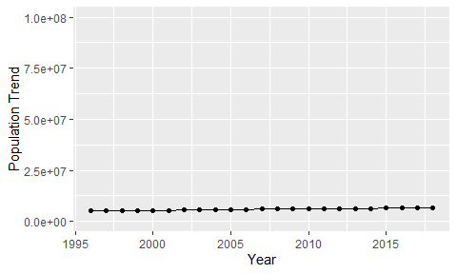

Political Stability Trend

# Population growth graph

The plot shows the population growth rate trend of the country.

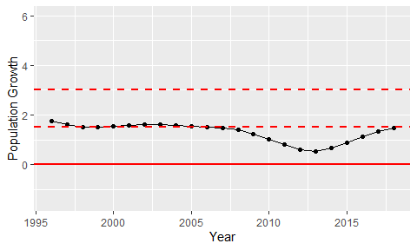

Population Growth Trend